***ZEISS VIEW***

***Software***

***Requirements***

***Specification***

***Version:*** *0.01*

***Status:*** *0.01*

***Prepared by:***

*Velizar Vasilev / Project Manager*

*Hristian Petakov / UX/UI designer*

*Boris Daskalov/ Front-End Dev*

*Tony Todorov/ Back-End Dev*

*Ilia Lulin/ QA*

1. **Introduction**
   1. ***Purpose***

This document aims to provide an extensive overview of the sunglasses website, delineating its purpose, functionalities, and interface specifics. It serves as a comprehensive guide for both stakeholders and developers involved in the platform. Within these pages, you'll find a thorough elucidation of the platform's objectives, its key features, and a detailed outline of its user interfaces, elucidating what the platform seeks to accomplish.

|  |  |  |
| --- | --- | --- |
| **ID** | **Stakeholder** | **Description** |
| S-1 | Customer | Reviewing the alignment between business objectives and functional requirements to ensure they meet the expectations of implementing the product. |
| S-2 | Development team | Forming the accurate vision of the project, detailed functional and nonfunctional requirements. |
| S-3 | QA team | Making test-plans and test-cases. |
| S-4 | Project Manager | Estimating the quote of the project, planning resources and the timeline of work. |
| S-5 | User | Based on this document the Terms of Service and the Privacy Policy are created. |

* 1. ***Intended Audience***

* 1. ***Product Scope***
* Login / Register in application for free.
* Customer can create a custom sunglasses.
* Application notifications.
* Provide a variety of sunglasses.
* Provide statistics for user purchases number in time (day, month and year).

1. **Overall Description**
   1. ***Product Perspective***

* User account: The application allows the user to create their accounts in the system and provide features of updating and viewing profiles.
* Number of users being supported: The application is able to support a large number of online users at a time.
  1. ***Product Functions***

The major functions which the product performs are:

* A wide variety of sunglasses.
* 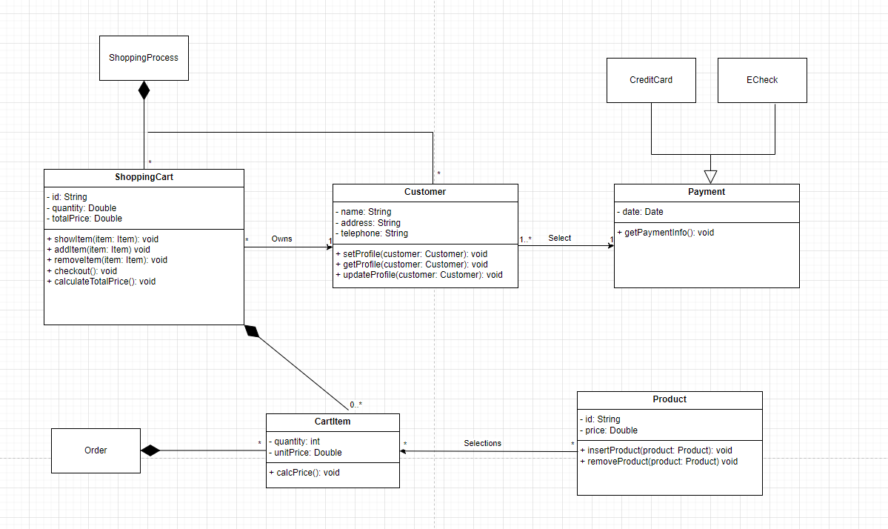To provide an opportunity to create custom sunglasses.
  1. ***User Classes and Characteristics***

|  |  |  |
| --- | --- | --- |
| **ID** | **User classes** | **Description** |
| U-1 | Signed up user | A user who has completed the sign-up process on the app and successfully activated their account. |
| U-2 | Not signed up user | A user who has completed neither the sign up in the application, nor the account activation. He owns limited rights inside the app. |

* 1. ***Operating Environment***

The hardware which is necessary to visit the website is any operation system.

* 1. ***Design and Implementation Constraints***
* For user authentication (login or registration), the system will rely on OAuth 2.0 protocol, ensuring secure and standardized authentication processes.
* JSON (JavaScript Object Notation) will serve as the primary data exchange format, enabling lightweight and efficient communication between the frontend and backend systems.
* Database development will be carried out using PL/SQL, leveraging its powerful features for efficient data management and querying.
* HTTP communication protocol will be utilized for client-server communication, ensuring interoperability and compatibility across different platforms and devices.
* Design conventions and programming standards will be established and enforced by our company, promoting consistency, readability, and maintainability of the codebase.
* Security measures will include hashing of users' passwords using industry-standard algorithms like Bcrypt, ensuring that sensitive information remains protected even in the event of a data breach.
  1. ***User Documentation***

User Documentation will be available on the website under the “User Documentation” section.

1. **External Interface Requirements**
   1. ***User Interfaces***

When the user opens the website he/she accesses the Login screen but if he/she is not registered, it’s necessary to make it (or login with social media account from left bottom corner). After the user is logged in, he/she will see the Home page where there are have a different type of sunglasses. The user can create a custom sunglasses from “Customize” menu. The button in the right corner is for logout.

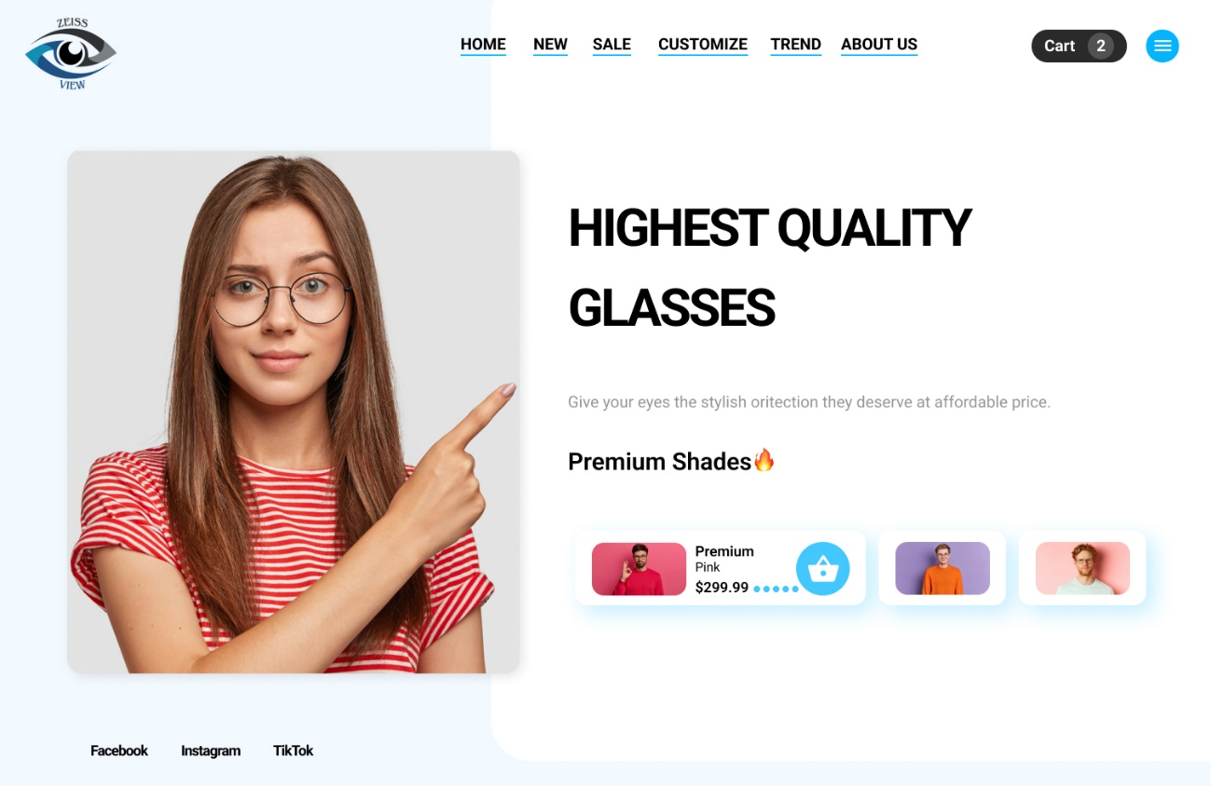

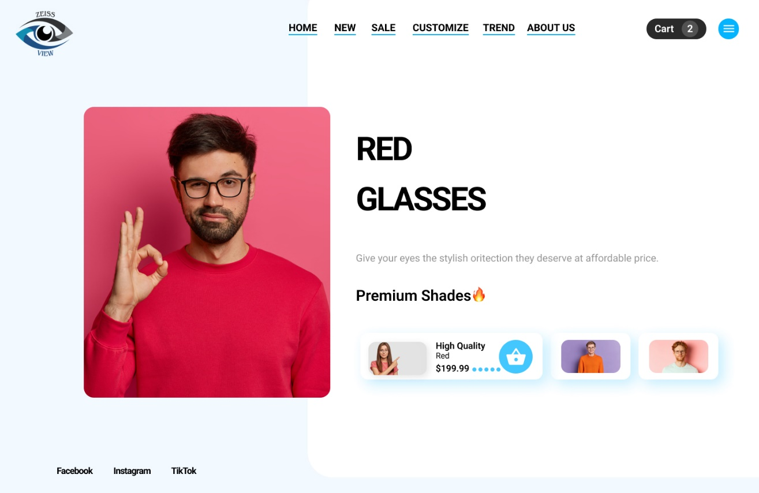

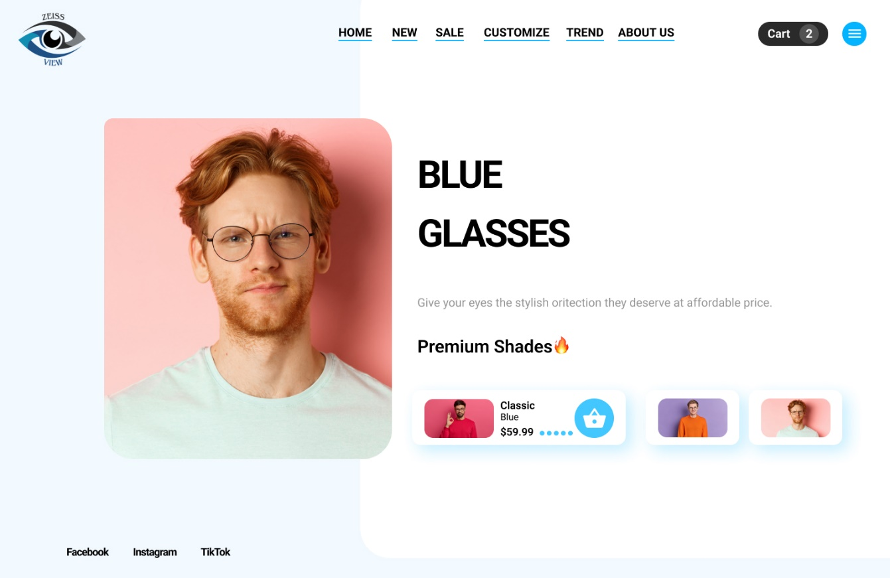

* 1. ***Hardware Interfaces***

There are no restrictions about devices. All you need is a device with internet access.

* 1. ***Software Interfaces***

The site is uploaded on Bluehost. PL/SQL developer is our database tool and Eclipse is the IDE which we use for our Java back-end project. Visual Studio code is our choice for front-end project.

* 1. ***Communications Interfaces***

We utilize communication protocols such as HTTP, SSL, etc. A wireless internet connection is essential for the device.

1. **Domain model**

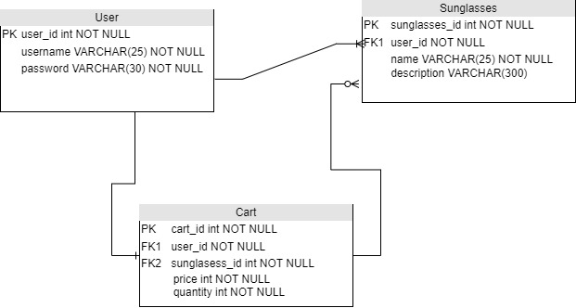

The Cart table has two columns (”user_id” and ”sunglasses_id”) that rely on the ”user_id” column from the User table and the ”sunglasses_id” column from the Sunglasses table respectfully. The column “user_id” in the Sunglasses table relies on the column ”user_id” from the User table.

1. **System features (Use Cases)**
   1. ***Use Case: Create Custom Sunglasses***

|  |  |  |  |  |  |  |
| --- | --- | --- | --- | --- | --- | --- |
| **Brief**  **Description:** | | | The user will create a new custom sunglasses. | | | |
| **Business Trigger:** | | | The business event is the user’s desire to create new sunglasses. | | | |
| **Preconditions:** | | | The user must be logged in the application. | | | |
| **Basic Flow:**  The user successfully logs in the application. He/She navigates through the menu and reaches the button for creating a new custom sunglasses (Customize). A new screen loads up and prompts the user to select at least at least one frame and lens type for the glasses. When the user is satisfied with his/her sunglasses, he/she will continue to payment method. After that he/she will fill the required information for shipping and finish the order. | | | | | | |
| **Assumptions:** 001 | | | | | | |
| **Line** | **System Actor Action** | | | | **System Response** | |
| 1 | The user wants to log in the application. | | | | The system asks the user for identification. | |
| 2 | The user identifies themselves to the system. | | | | The system returns the user to the home screen. | |
| 3 | The user navigates through the menu and selects the button Customize. | | | | The system loads up a new screen and prompts the user to select at least at least one frame and lens type for the glasses. | |
| 4 | The user finish order. | | | | The system returns the user to the home page. | |
| **Post Condition:** | | The system save order in the database. | | | | |
| **Alternate Flow (AFx): 0001 Failed login in the application** | | | | | | |
| If at line 2 in Create Custom Workout the user fails to correctly identify themselves, the system will prompt the user to either reset their password or give them an option to create a new account. | | | | | | |
| **Line** | **System Actor Action** | | | | | **System Response** |
| 1 | The user fails to correctly identify themselves. | | | | | The system will prompt the user to either reset their password or give |
| The use case terminates / The use case restarts at line 1 in Customize. | | | | | | |
| **Post Condition:** | | | | The system returns the user to the login page | | |  |

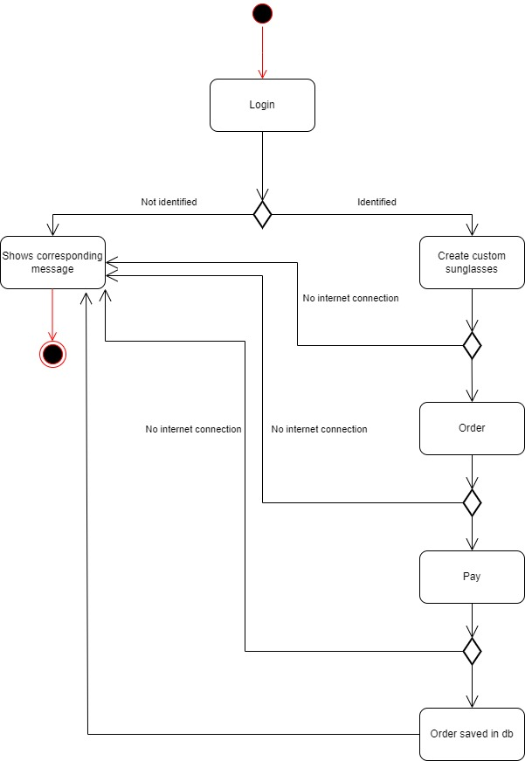

* 1. ***Use Case: Open “Trend” tab***

|  |  |  |  |  |  |  |
| --- | --- | --- | --- | --- | --- | --- |
| **Brief**  **Description:** | | | The user will open Trend menu. | | | |
| **Business Trigger:** | | | The business event is the user’s desire to open trends. | | | |
| **Preconditions:** | | | None. | | | |
| **Basic Flow:**  The user successfully open the website. He/She navigates through the menu and reaches the button for open Trend. | | | | | | |
| **Assumptions:** 002 | | | | | | |
| **Line** | **System Actor Action** | | | | **System Response** | |
| 1 | The user navigates through the menu and selects the button Trend. | | | | The system loads up a new screen and shows the trends in sunglasses. | |
| **Post Condition:** | | None. | | | | |
| **Alternate Flow (AFx): 0002 Failed to open Trends** | | | | | | |
| If the user’s network connection stops when he/she open the Trends men, he/she will receive a message. It’s necessary the application to show dialog with message “No internet connection”. | | | | | | |
| **Line** | **System Actor Action** | | | | | **System Response** |
| 1 | The user’s network connection stops | | | | | Website show dialog with message “Please, check your internet connection”. |
| The use case terminates / The use case restarts at line 1 in basic flow. | | | | | | |
| **Post Condition:** | | | | 0002 The user will receive a message to check his/her internet connection and the app returns to the workouts page. | | |

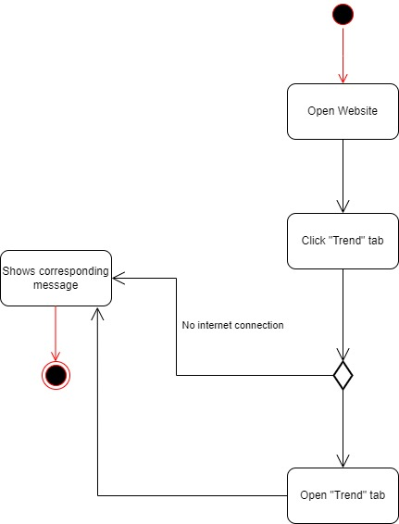

1. **Other Nonfunctional Requirements**
   1. ***Performance Requirements***

The load of the initial screen should take around 2 seconds. The user data(caches, etc.) increases and the application should be capable of handling them without delay.

* 1. ***Security and safety Requirements***

User data will be encrypted with RSA algorithm and saves in database. Also, he/she can use 2FA for logging in website.

* 1. ***Software Quality Attributes***

We must prioritize the versatility, adaptability, and accessibility of our company's codebase. It's essential to maintain a framework that is easily transferable, readily modifiable, and receptive to enhancements and fixes. Additionally, we must emphasize key attributes such as reusability, dependability, verifiability, and user-friendliness.